**May 2018181729mportant Dates** 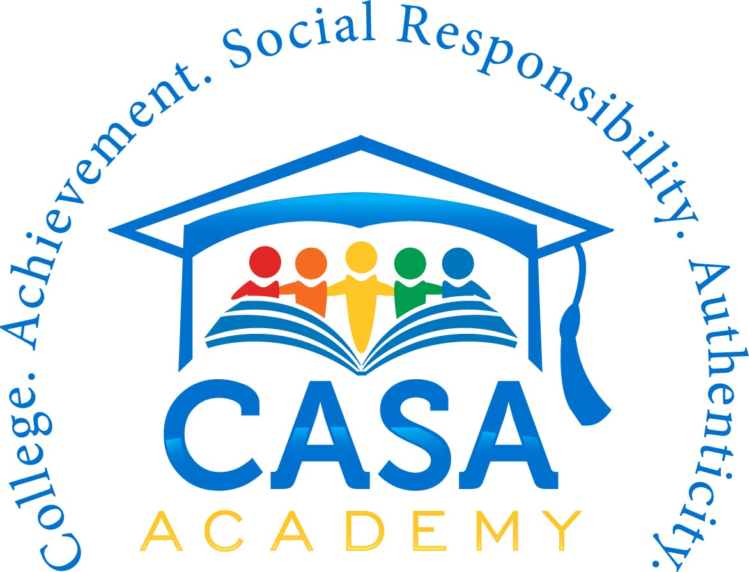

**2017-18 School Year Calendar**





**2017-18 School Year Important Dates**

|  |  |
| --- | --- |
| **July 2017**  **July 17 - 31:** Staff Professional Development (PD) | **January 2018**  **January 1:** New Year’s Day; No School  **January 2:** No School for Scholars; Staff PD  **January 15:** Martin Luther King, Jr. Day; No School  **January 17:** Quarter 2 Ends  **January 26:** Q2 Report Cards Sent Home; 100th Day of School |
| **August 2017**  **August 7:** First Day of School | **February 2018**  **February 19:** President’s Day; No School |
| **September 2017**  **September 4:** Labor Day; No School  **September 5:** No School for Scholars; Staff PD | **March 2018**  **March 12-16:** Spring Break; No School  **March 19:** No School for Scholars; Staff PD  **March 28:** Quarter 3 Ends |
| **October 2017**  **October 9-13:** Fall Break; No School  **October 16:** No School for Scholars; Staff PD  **October 18**: Quarter 1 Ends  **October 27:** Q1 Report Cards Sent Home | **April 2018**  **April 6:** Q3 Report Cards Sent Home |
| **November 2017**  **November 10:** Veteran's Day Observed; No School  **November 22-24:** Thanksgiving Break; No School | **May 2018**  **May 28:** Memorial Day; No school  **May 30:** Last Day of School; Q4 Ends; Q4 Report Cards Sent Home; Early Release Day |
| **December 2017**  **December 18-29:** Winter Break; No School |